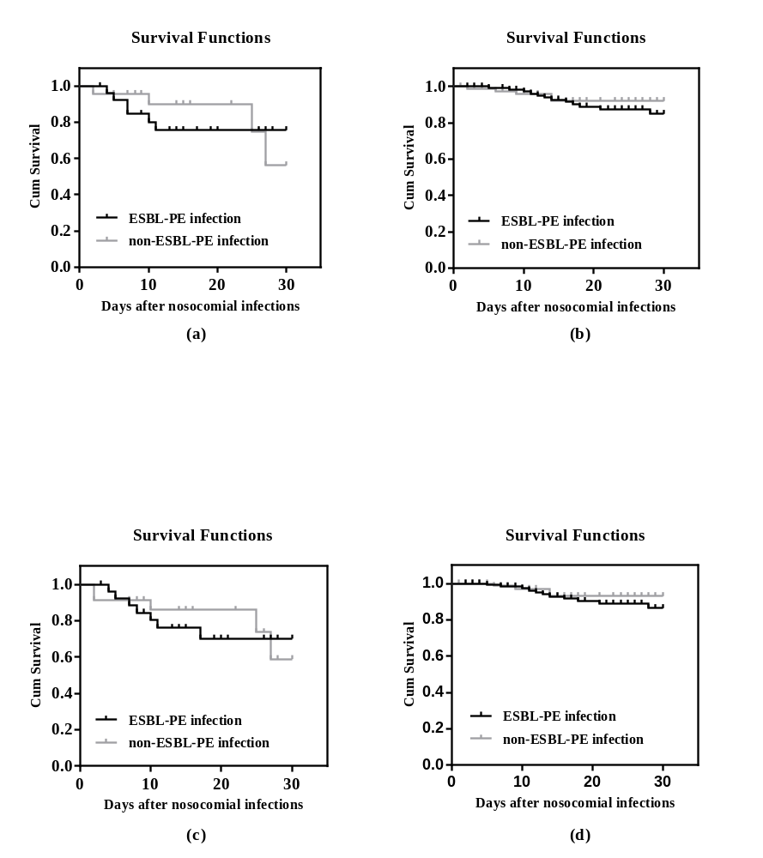
Fig. S1 Kaplan-Meier survival estimates among cancer patients with nosocomial infections caused by ESBL-PE and non-ESBL-PE. (a) Bloodstream infection (22.2% vs. 17.4%; χ2=0.056, P=0.814). (b) Non-bloodstream infection (9.4% vs. 5.7%; χ2=0.511, P=0.475). (c) Septic shock (25.9% vs. 21.7%; χ2=0.078, P=0.779). (d) Non-septic shock (8.6% vs. 4.6%; χ2=0.712, P=0.399)

